Gaming-Bets

Use-Case Specification: Manage User Data (User)

Version 1.0

Revision History

|  |  |  |  |
| --- | --- | --- | --- |
| **Date** | **Version** | **Description** | **Author** |
| 03.11.2015 | 1.0 | Basic Information | Felix Morsbach |
|  |  |  |  |
|  |  |  |  |
|  |  |  |  |

Table of Contents

1. Use-Case Name 4

1.1 Brief Description 4

2. Flow of Events 4

2.1 Basic Flow 4

2.2 Alternative Flows 5

2.2.1 Ticket can not reach server 5

3. Special Requirements 5

4. Preconditions 5

4.1 App started 5

4.2 Internet Connection 5

4.3 Response possibility 5

5. Postconditions 5

5.1 Notification if feedback is successfully submitted 5

6. Extension Points 5

Use-Case Specification: Feedback

# Use-Case Name

## Brief Description

This Use-Case will provide the possibility to edit your personal profile data, if logged in

# Flow of Events

## Basic Flow

## 



This may not be the final version, for current version check [here](https://github.com/GamingBets/documents/blob/master/Use%20Case/Manage%20User%20Data/manage_user_data.png):

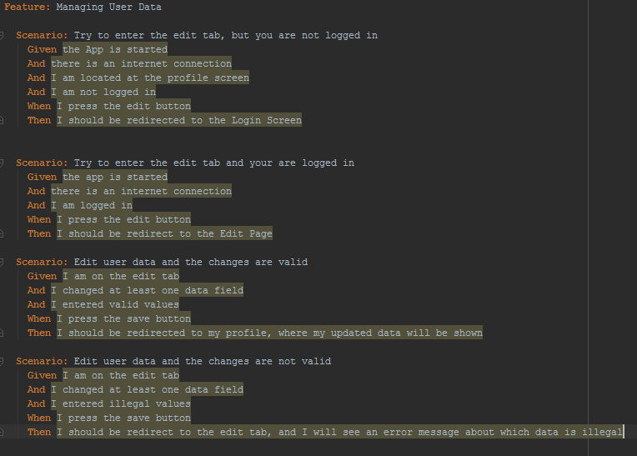

This may not be the final version, for current version check [here](https://github.com/GamingBets/documents/blob/master/Use%20Case/Manage%20User%20Data/feature.PNG):

## Alternative Flows

### Cannot reach server

If the changes cannot be transmitted to the server, the user will be notified if possible via app. He will be asked to try it again later.

# Special Requirements

n/a

# Preconditions

## App started

The app must be running.

## Internet Connection

To submit feedback or a message, an internet connection is necessary.

## User must be logged in

To manage your personal user data, you have to be logged in.

# Postconditions

## Notification and redirection

As soon as the changes were done by the system, the user will be notified about the success and will be redirected to the personal profile.

# Extension Points

n/a